US Year 10 Edexcel – Pre-test
20 Questions | 60 minutes | Calculator allowed
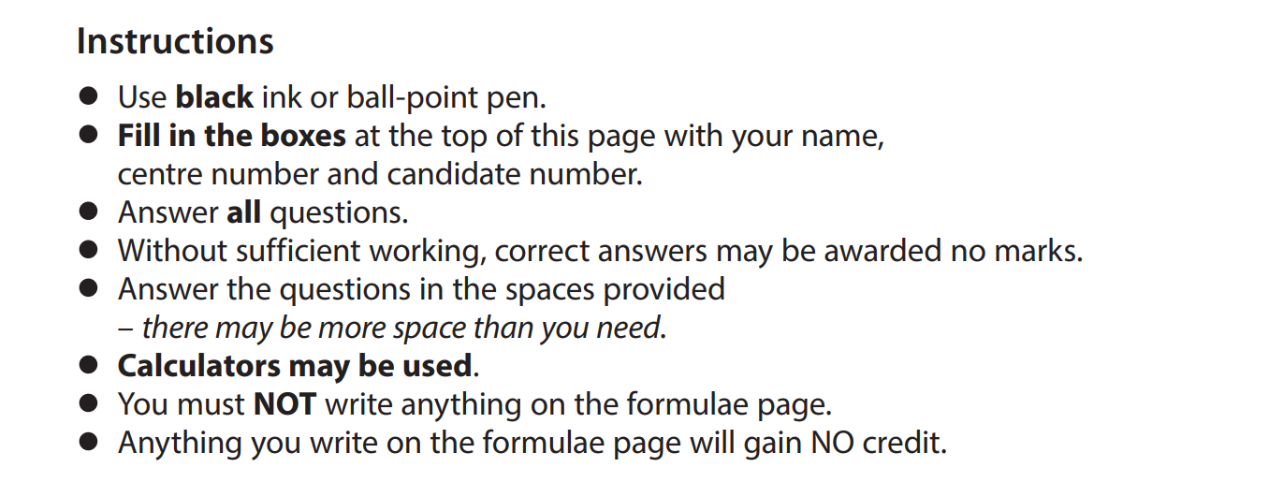

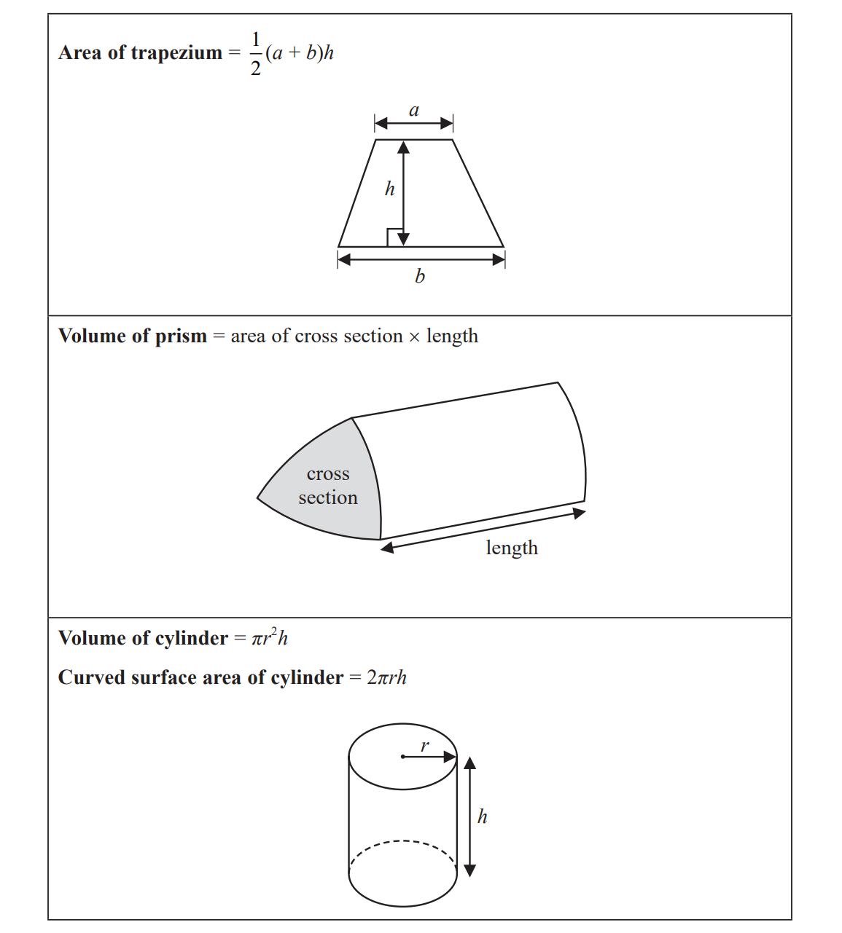

1. Answer the following questions.
a) Write the number 7823 correct to the nearest hundred.

___________________________________

b) Write down four factors of 18.

___________________________________

c) Write down a prime number between 90 to 100.

___________________________________

2. Here are the first five terms of a number sequence.
11 15 19 23 27
- Write down the next term of the sequence.
___________________________________

- The 14th term of the sequence is 63
Find the sum of the 16th term and the 17th term of the sequence.
___________________________________

- Is 98 a term of the sequence. Show your proof.

____________________________________

3. The pictogram gives information about the number of kilometres Thomas travelled on
Monday, on Tuesday, on Wednesday and on Thursday.
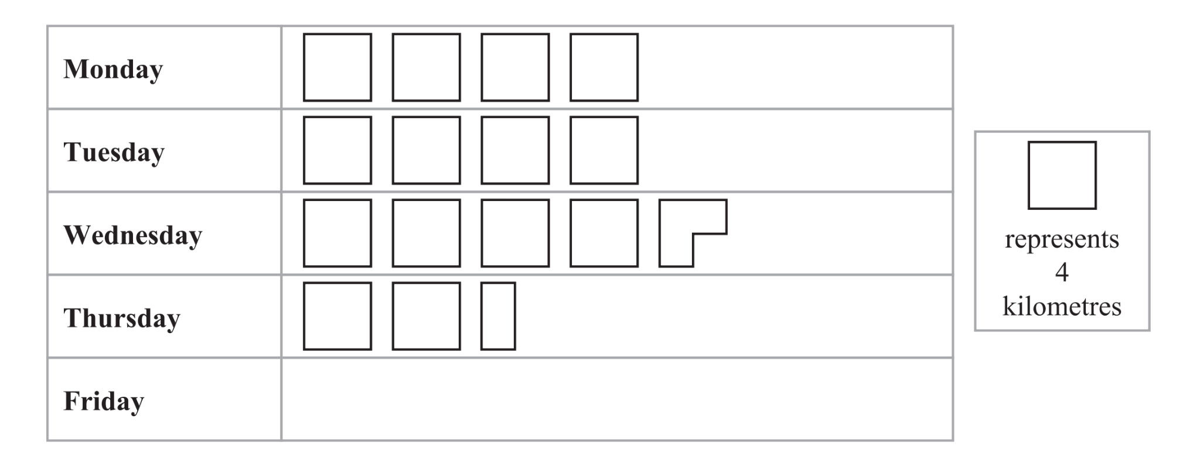
- On Wednesday, Thomas travelled further than he did on Thursday.
How much further?

_________________________ kilometres

- On Friday, Thomas travelled 13 kilometres.
Show this information on the pictogram

4. There are 80 crayons in a box.
$\frac{2}{5}$ of the crayons are red.
Work out the number of crayons that are not red.

_________________________

5. The table shows information about the shoe sizes of the 25 children in a nursery class.
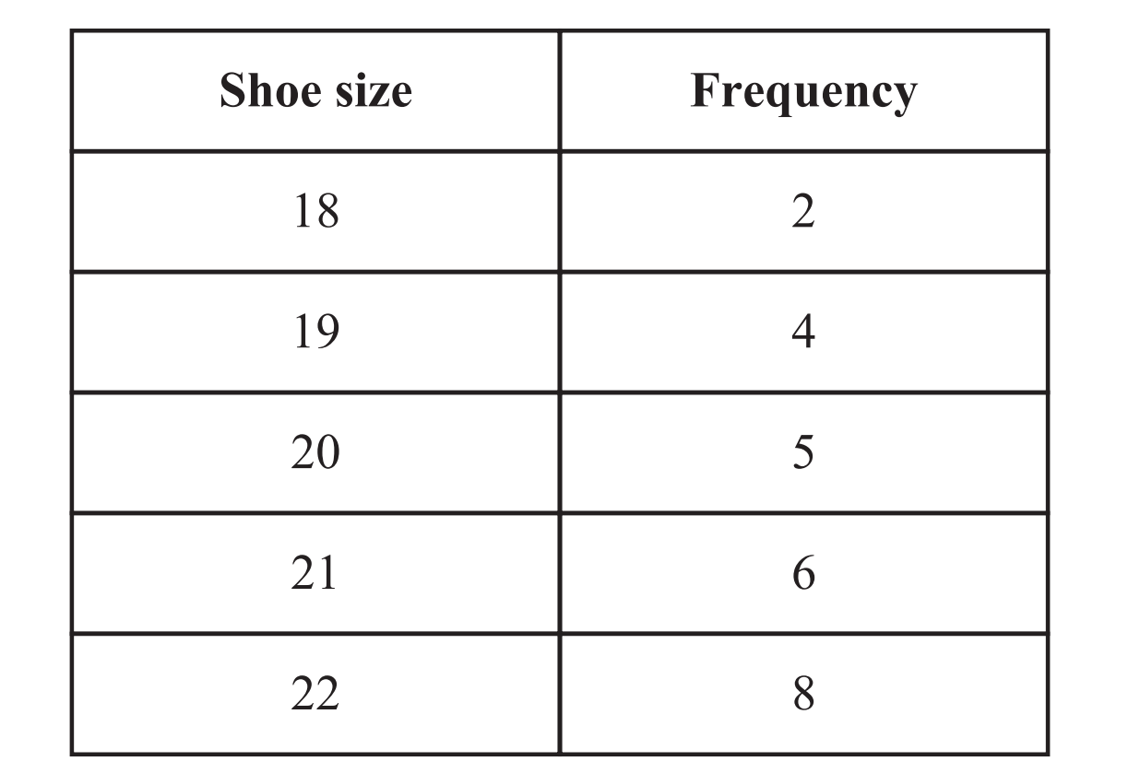
Find the median shoe size.

_________________________

6. The table shows information about the temperatures at different heights above sea level.

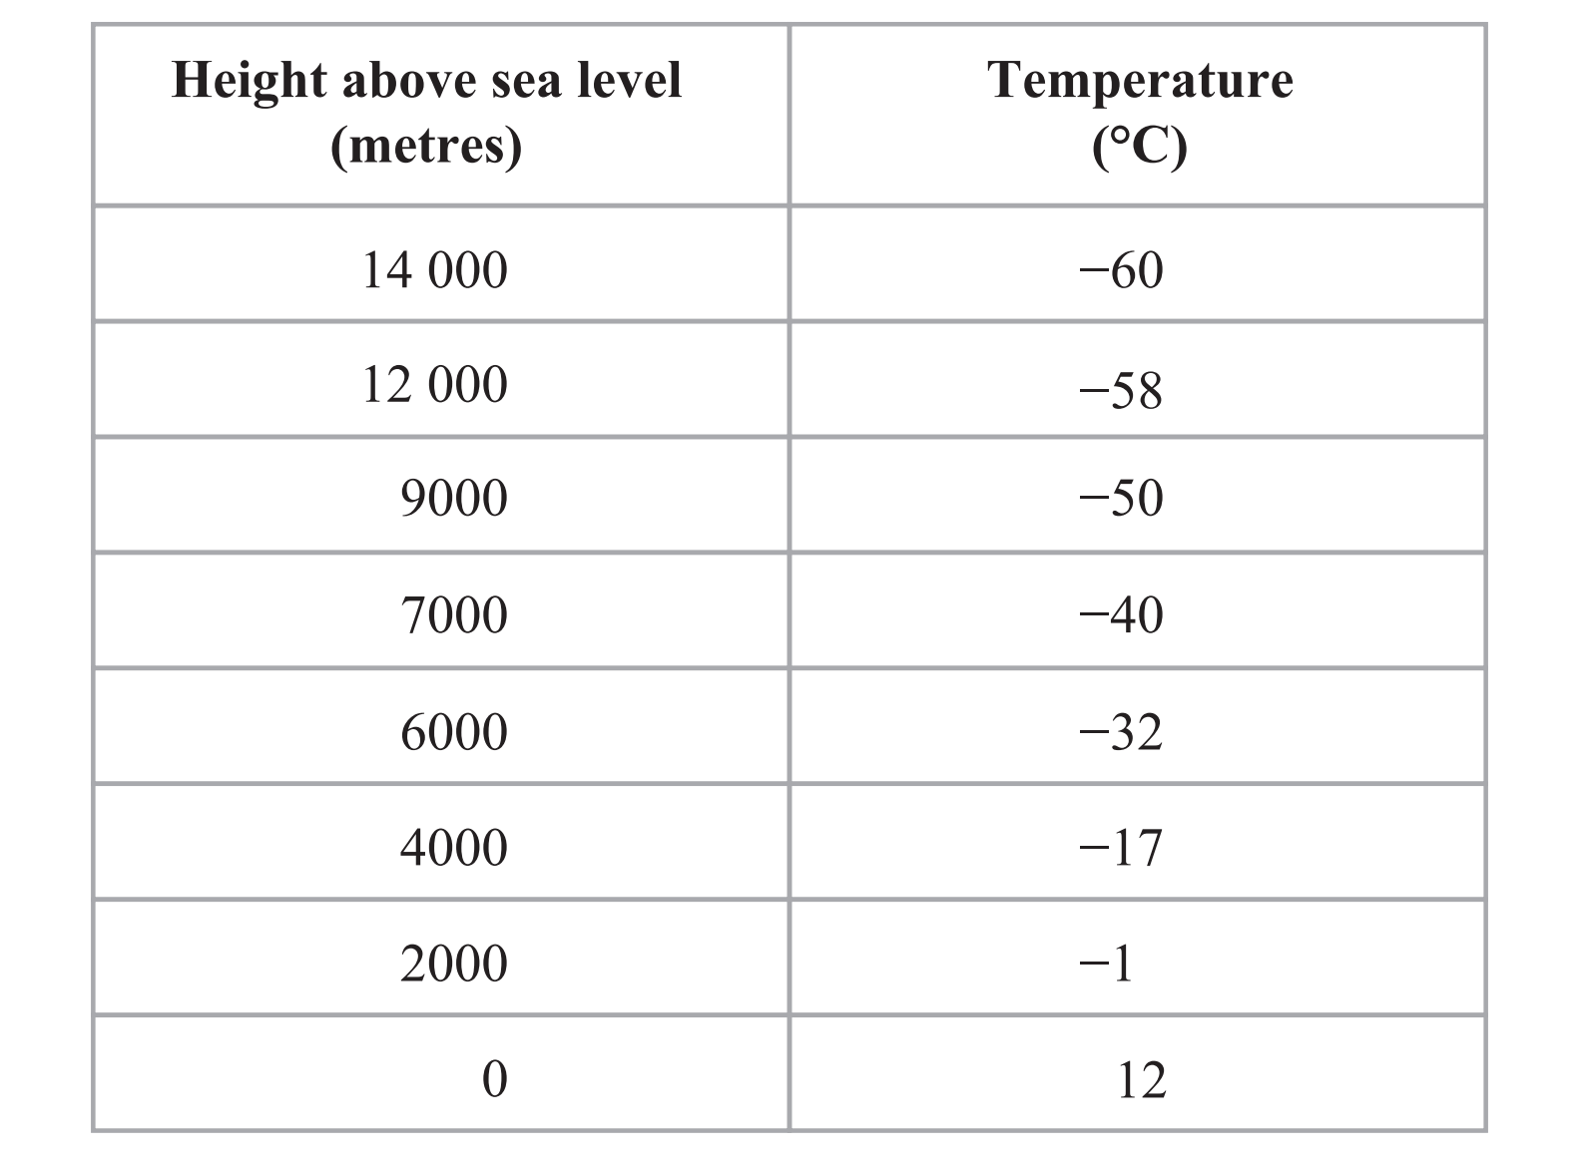

- Work out the difference in temperature between a height of 0m and
a height of 12000m

_________________________°C

- Work out the difference in temperature between a height of 4000m and
a height of 6000m

_________________________°C

- At what height is the temperature 10°C warmer than the temperature at
a height of 9000m?

_________________________m
7. Answer the following questions.
- Simplify $7g+3h+4g-5h$

_________________________

- Simplify $7a×a×4m$

_________________________

- Solve $5x-7=12$

$x=$_________________________
- Expand $5(7k+3)$

_________________________
- Factorise $9y+12$

_________________________

8. Don got on a bus at 0735
He got off the bus at 1325
How long was Don on the bus?
Give your answer in hours and minutes.

_________________ hours _________________ minutes

9. Here is a cuboid.
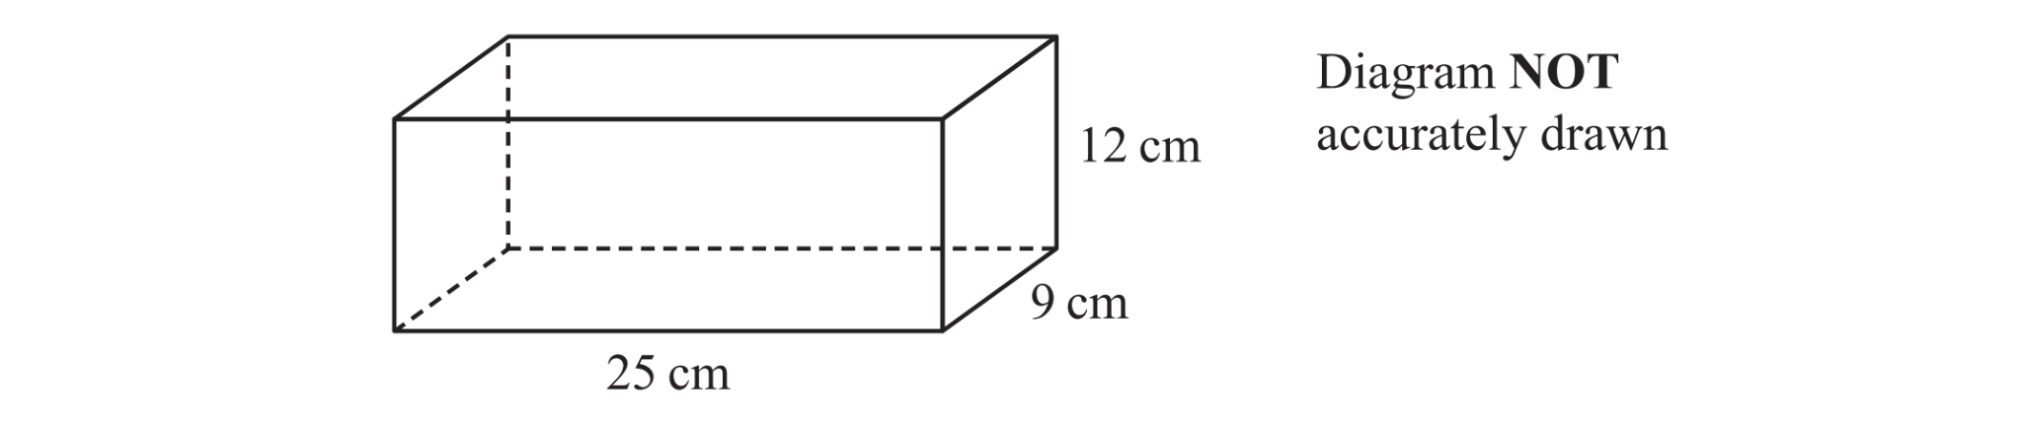
Work out the volume of the cuboid.

_________________________$cm^{3}$

10. Pierre used 2358 units of water last year.
Each unit of water cost 0.28 euros.
Pierre has already paid for some of the water he used.
He paid 42 euros each month last year.
Work out how much more Pierre has to pay for the water he used last year.

________________________________ euros

11. ABCD is a quadrilateral.
ADE is a straight line.
Work out the value of x
Give a reason for each stage of your working
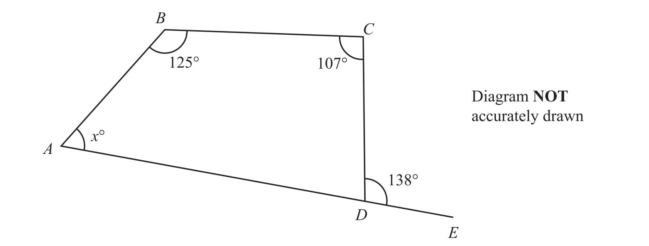

$x=$_________________________

12. Make$d$ the subject of the formula $c=8d+5$

_________________________
13. On the grid below, draw the graph of $y=\frac{1}{2}x-1$ for values of x from −2 to 3
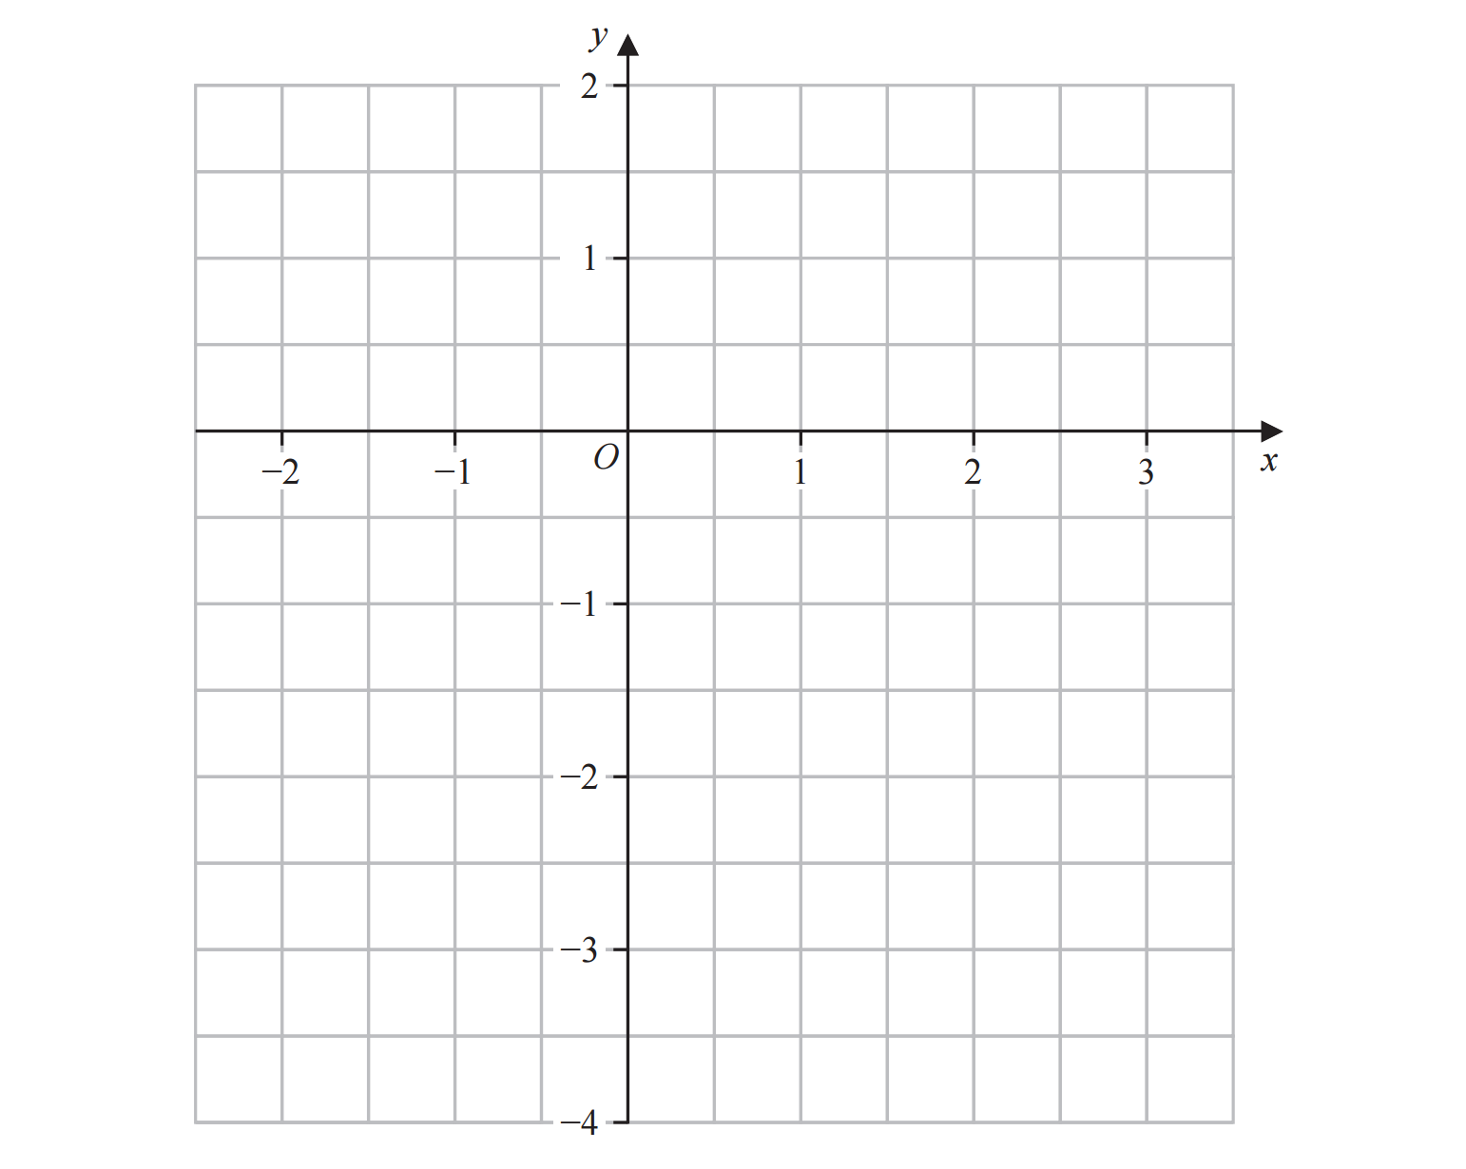

14. Rema buys 140 plants.
35% of the 140 plants cost $6 each.
$\frac{1}{4}$ of the 140 plants cost $8 each.
The rest of the 140 plants cost $10 each.
Work out the total cost of the 140 plants.

$ _________________________

15. The table shows some information about the hourly rates of pay of 60 workers.
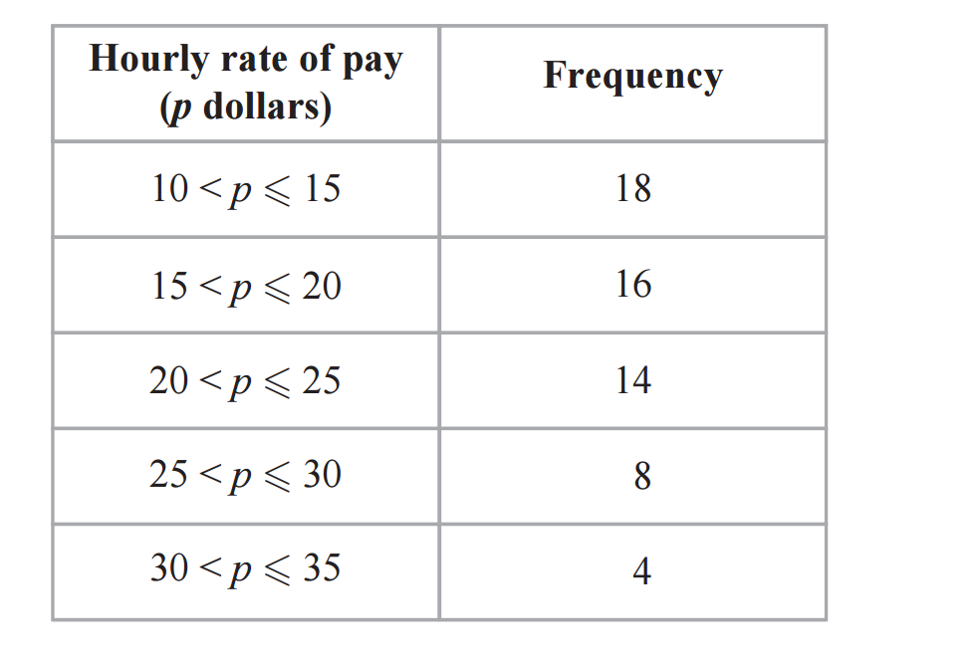
Work out an estimate for the mean hourly rate of pay of the 60 workers.

_________________________________ dollars

16. Answer the following questions
- Simplify $({p^{3})}^{5}$

_________________________

- Factorise $x^{2}+5x-24$

_________________________
- Solve $x^{2}+5x-24$

$x=$______________ , ____________
17. Here is a Venn diagram.
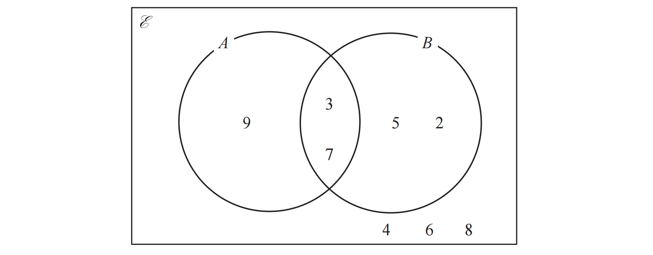
- List the members of the set $A'$

_________________________

- List the members of the set $A∩ B$

_________________________

18. The diagram shows a shape $ABCDE$ made from a square $ABDE$and an isosceles
triangle $BCD$
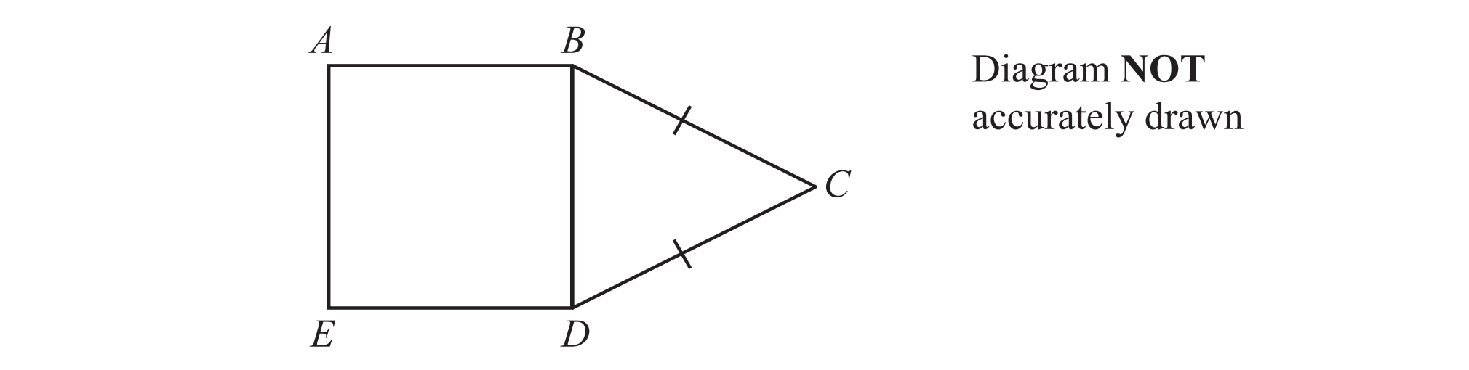
$BC=DC$
The area of square $ABDE$ is $49$$cm^{2}$
The perimeter of triangle $BCD$ is $27 cm$
Work out the perimeter of $ABCDE$

_________________________ $cm$
19.$A=2^{3}×5^{4}×7×11$
$B= 2^{2}×5^{2}×7^{2}$
$C=2^{2}×5^{3}×7^{4}$
Find the highest common factor (HCF) of A, B and C
Write your answer as a product of prime factors.

_________________________

20. The diagram shows triangle $PQR$
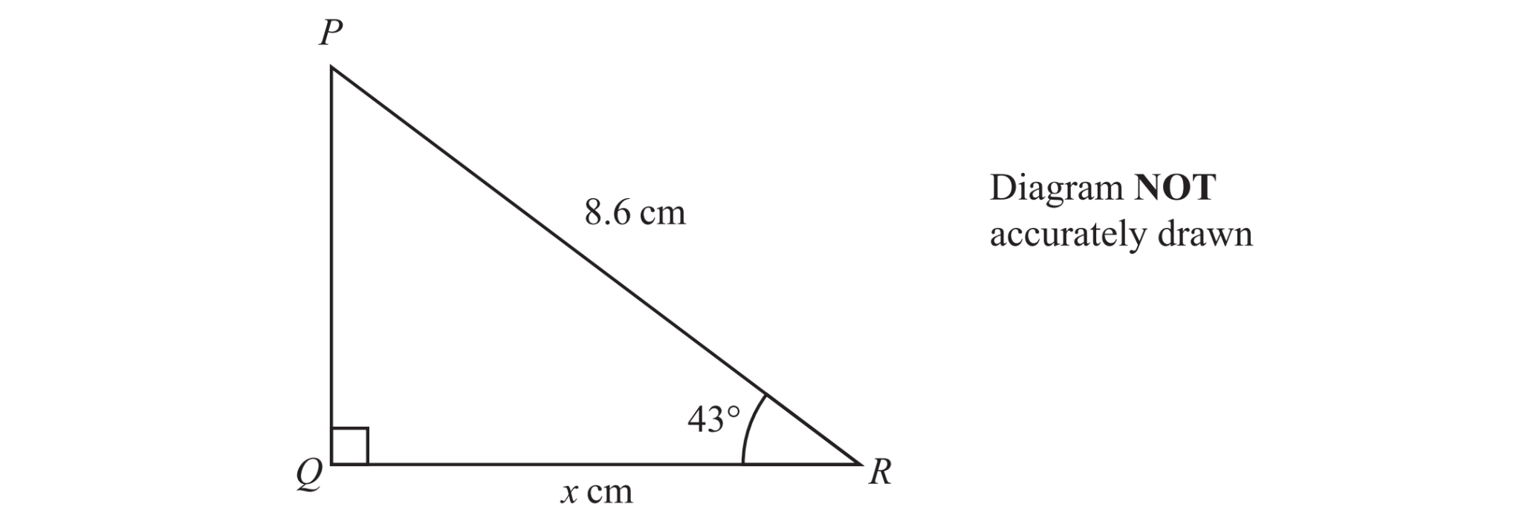

Work out the value of x
Give your answer correct to one decimal place.

$d=$_________________________

